Parents Newsletter
Spring Term 1

Asalam Alaikum / Peace be upon you all,
We pray you all had a lovely break and we would like to welcome our new parents to the nursery and pray your settling in has gone smoothly.
Please find below this terms theme and some activities that will be taking place:
Toddler: winter: looking at clothes and food (soup) that would keep us warm, stories on winter, role play area making different habitats.
Pre-sch: winter: changes from solid to liquid (ice), animals in the Antarctic, transport: (different modes of transport)
Islamic curriculum: Adab of dressing, dua for getting dressed and Looking at the Prophets in Islam.
(Please see photography’s of the activities from last term below)

Parents evening
We would like to thank all the parents who attended the parents evening in December, mashAllah it was great to see so many of our parents took time out to attend.

Food collection
We would like to thank all our parents who contributed to the collection, as some of you might know a reporter from the BBC covered the collection and it has appeared on-line on the BBC local news. From this we have received emails from local and national people expressing how it was nice to see a Muslim organisation in a positive light working in cohesion with local charities. If you missed the article you can find it on this link:
https://www.bbc.co.uk/news/uk-england-merseyside-46623082

Labelling clothes
Can we please ask all parents to label their child’s coats, lunch bag, clothes and the like so that we can ensure that everyone gets their child’s belongings back. You can do this with a permanent marker by initialling your child’s name on the tag in clothes or in the corner of a lunch box. If clothes are not labelled, the nursery cannot take responsibility for lost items. We thank you for your cooperation in this respect.

Parent Partnership
To help enhance what activities we plan for your child we would like to know your child’s interests and any activities/visits your child has participated in during weekends or half term. You can share this information either by completing the slip your key person will give to you or by filling in ‘all about your child’, which is located on the nursery door.

Lost Property
We will be leaving a box of lost property outside the entrance door over the coming week. Please go through the items in case anything belongs to your child. Any items left at the end of the term will either be disposed of or given to charity.

Children Transitioning from Toddler Room
We would like to remind parents of children moving from the Toddler room to the pre-school room that your child will no longer be using the ‘daily diary’. As children get older they are able to communicate to their parents about what they have been doing in nursery and so parents no longer need this as a tool for communication.

Snack and late pick up charges
If your child attends nursery with a free place through funding from the council, we would like to remind you that there is a 50p per day charge for snacks, which the children have in the afternoon.
We would also like to remind you to pick up your children at the end of the day promptly please as many of our staff leave the setting at 4pm and at times staff have meetings which start straight away. May we remind parents that our ‘Parent’s Pack’, given to you upon registration, states there is a £5 per five minutes charge for a late pick up of your child. We really do not like charging parents for this but have put the charge in place in order to deter parents from picking up their child late on a regular basis.

Thank you for taking the time to read our newsletter.
From all the staff at Happy Children Nursery

Dates for your Diary
Nursery closed 18th-22nd February for half term
Nursery Closed for Easter Break- starts 6th April- ends 23rd April

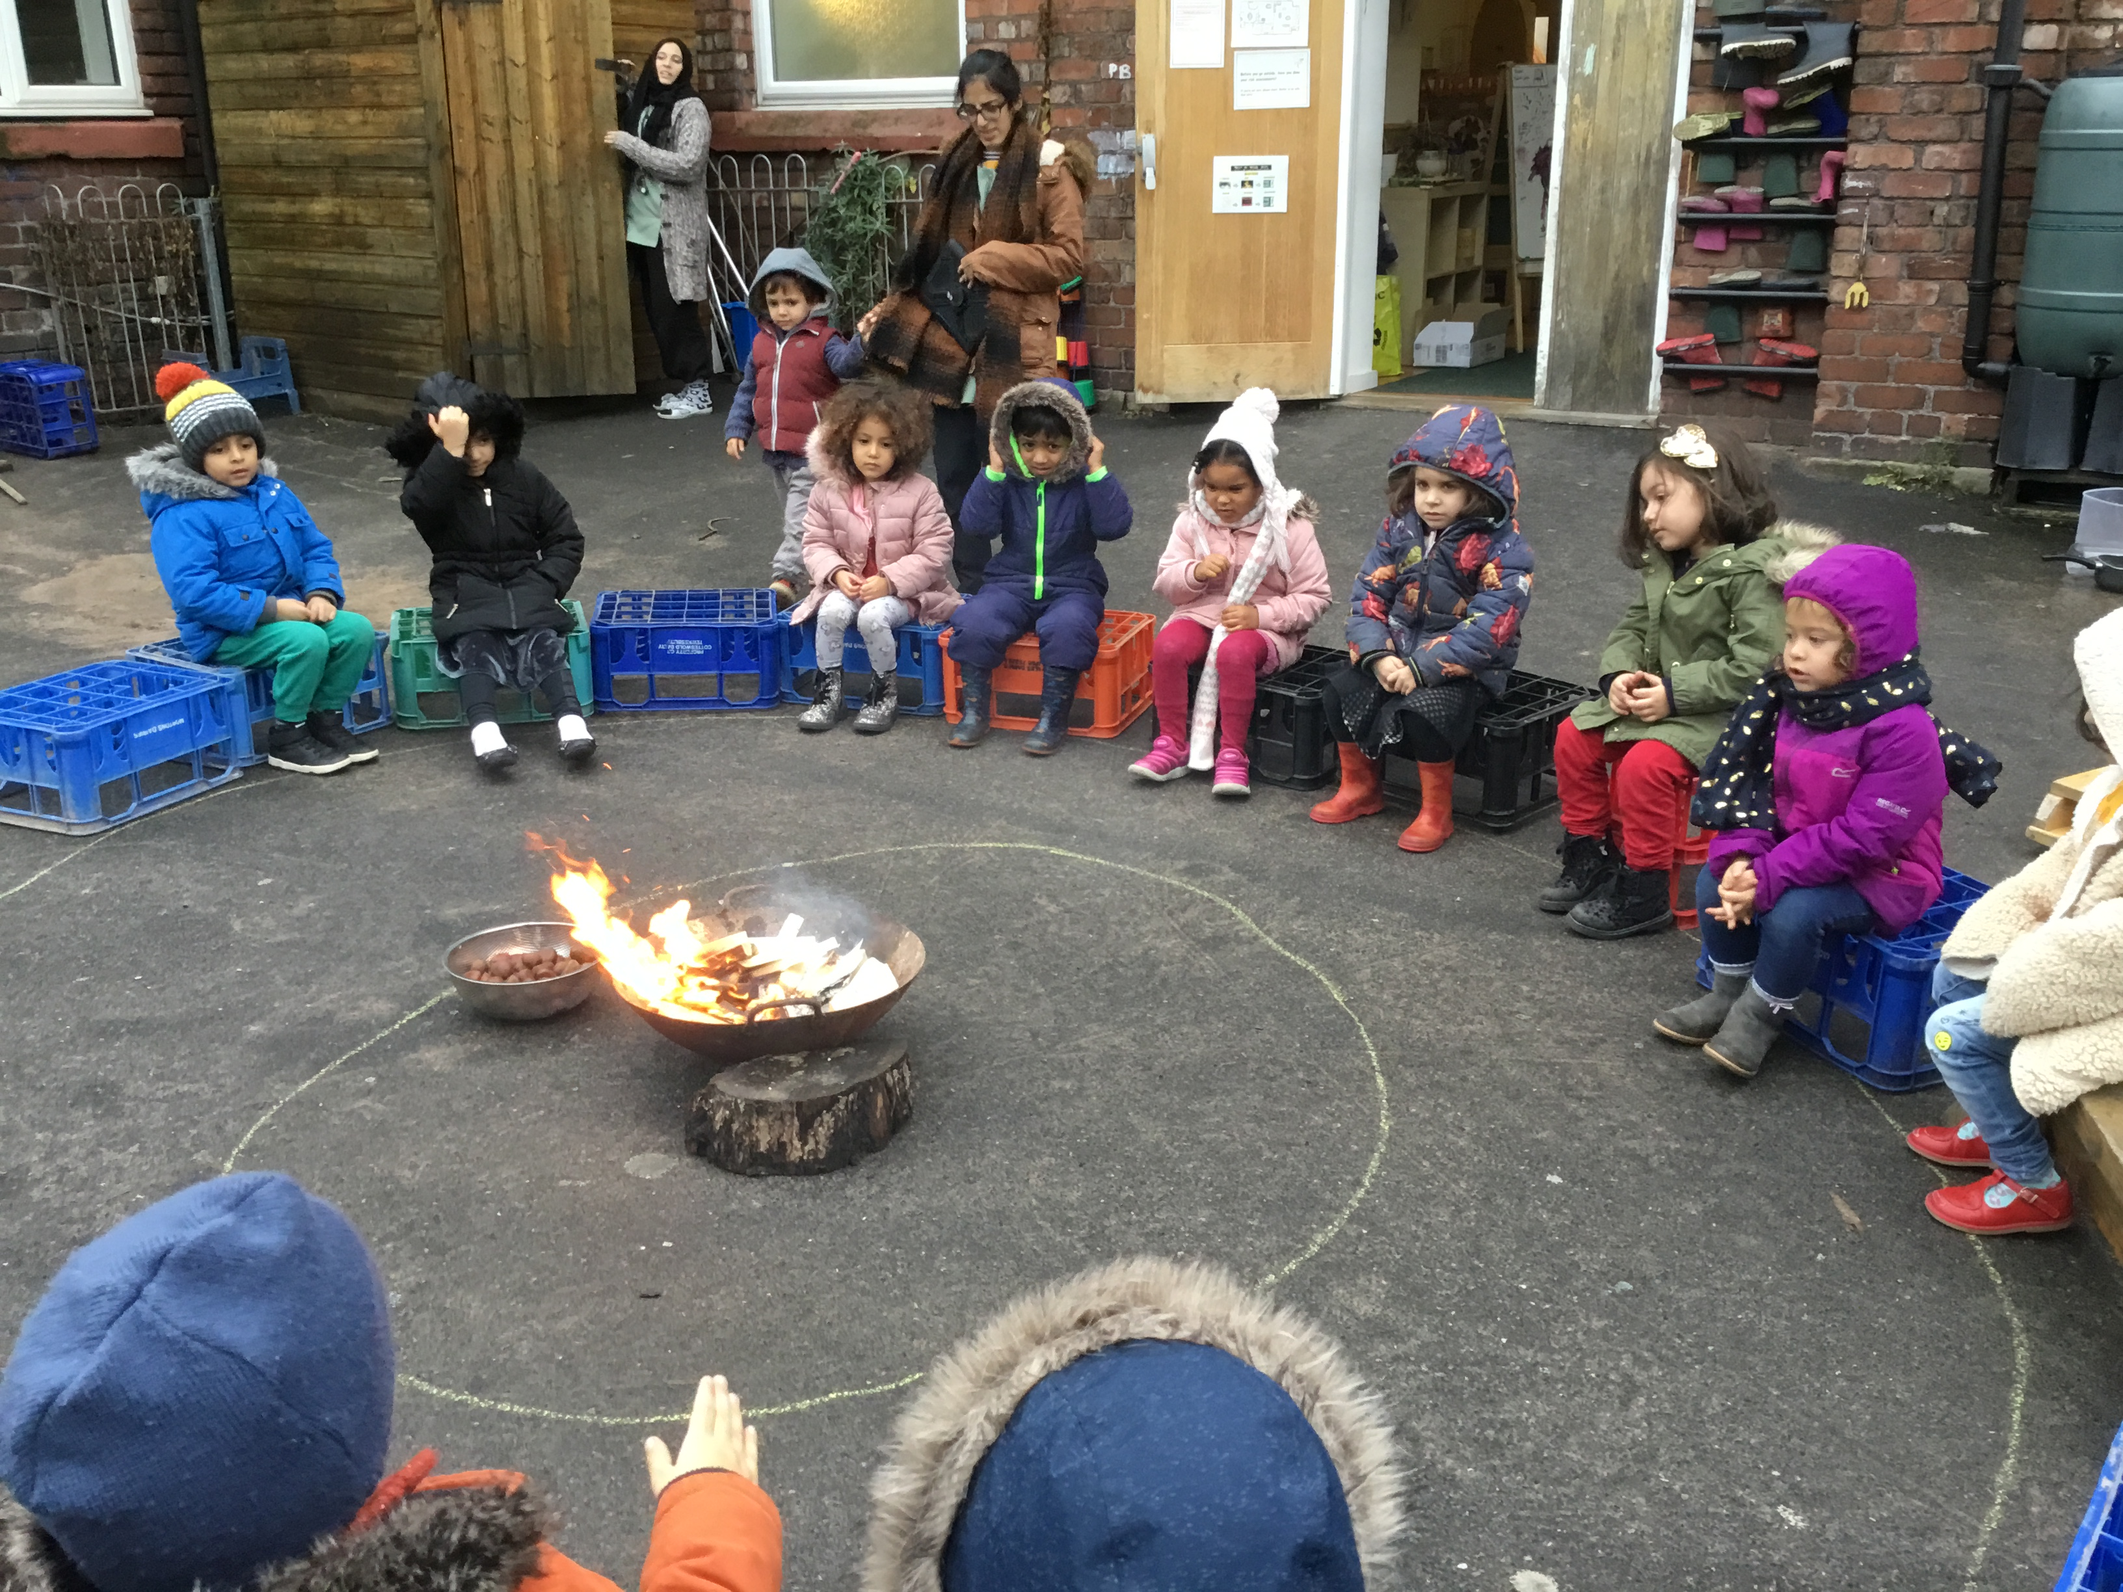
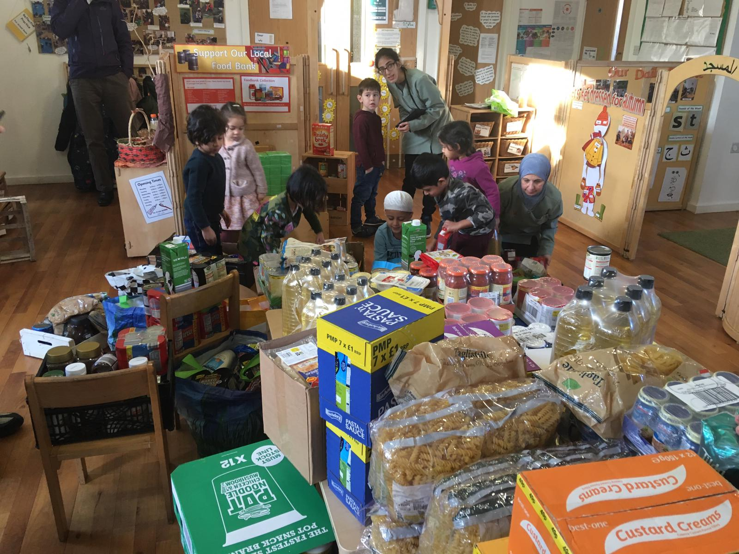
Food collection Roasting chestnuts around the open fire

A guest speaker (shaykh Haroon) came
to tells us about Prophet Eesa’s birth Doing mindfulness
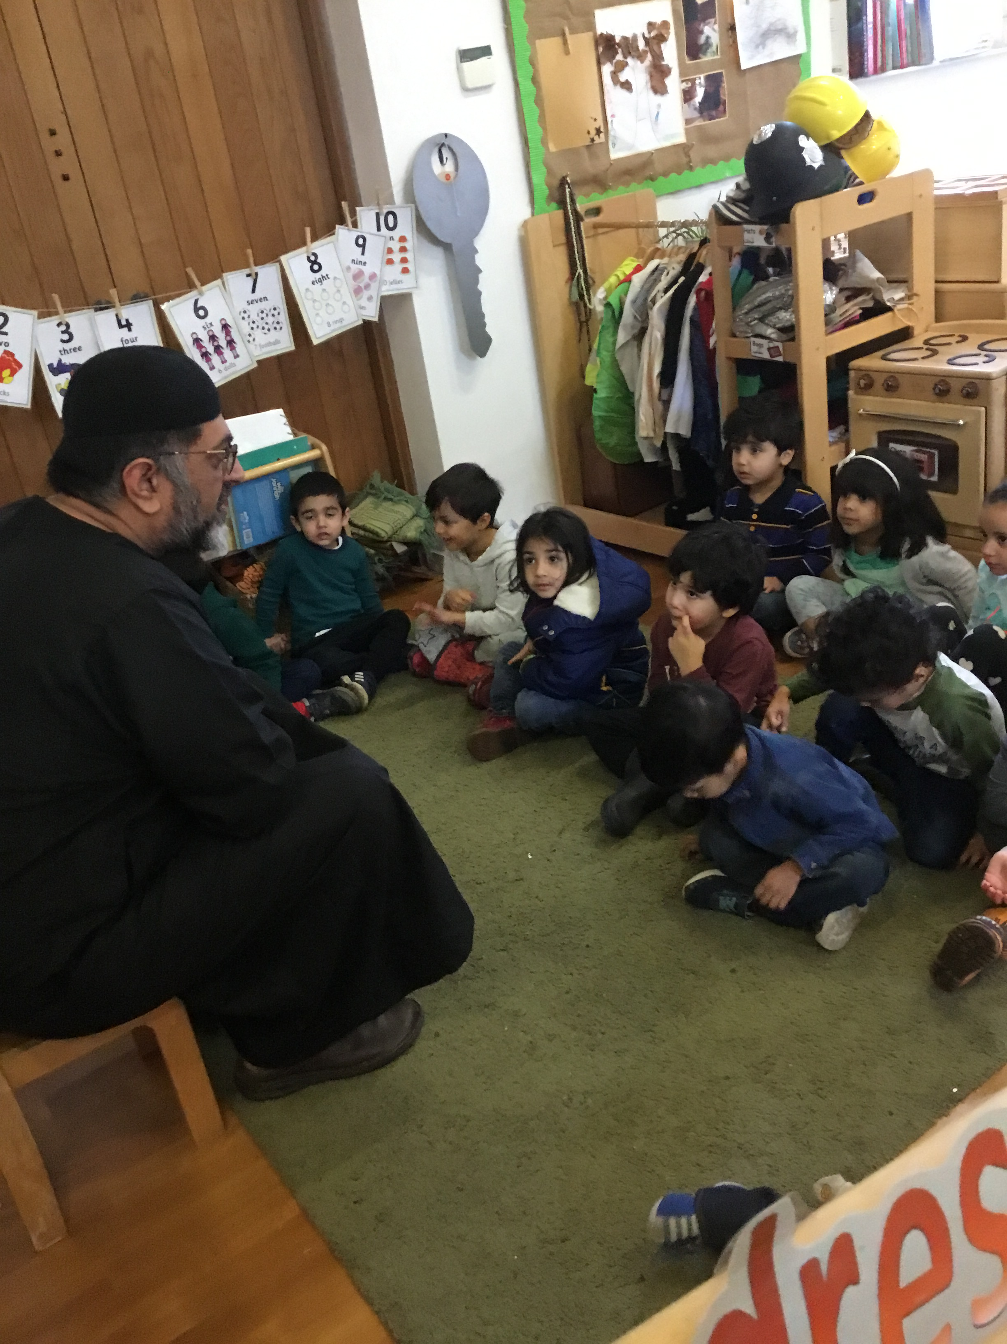
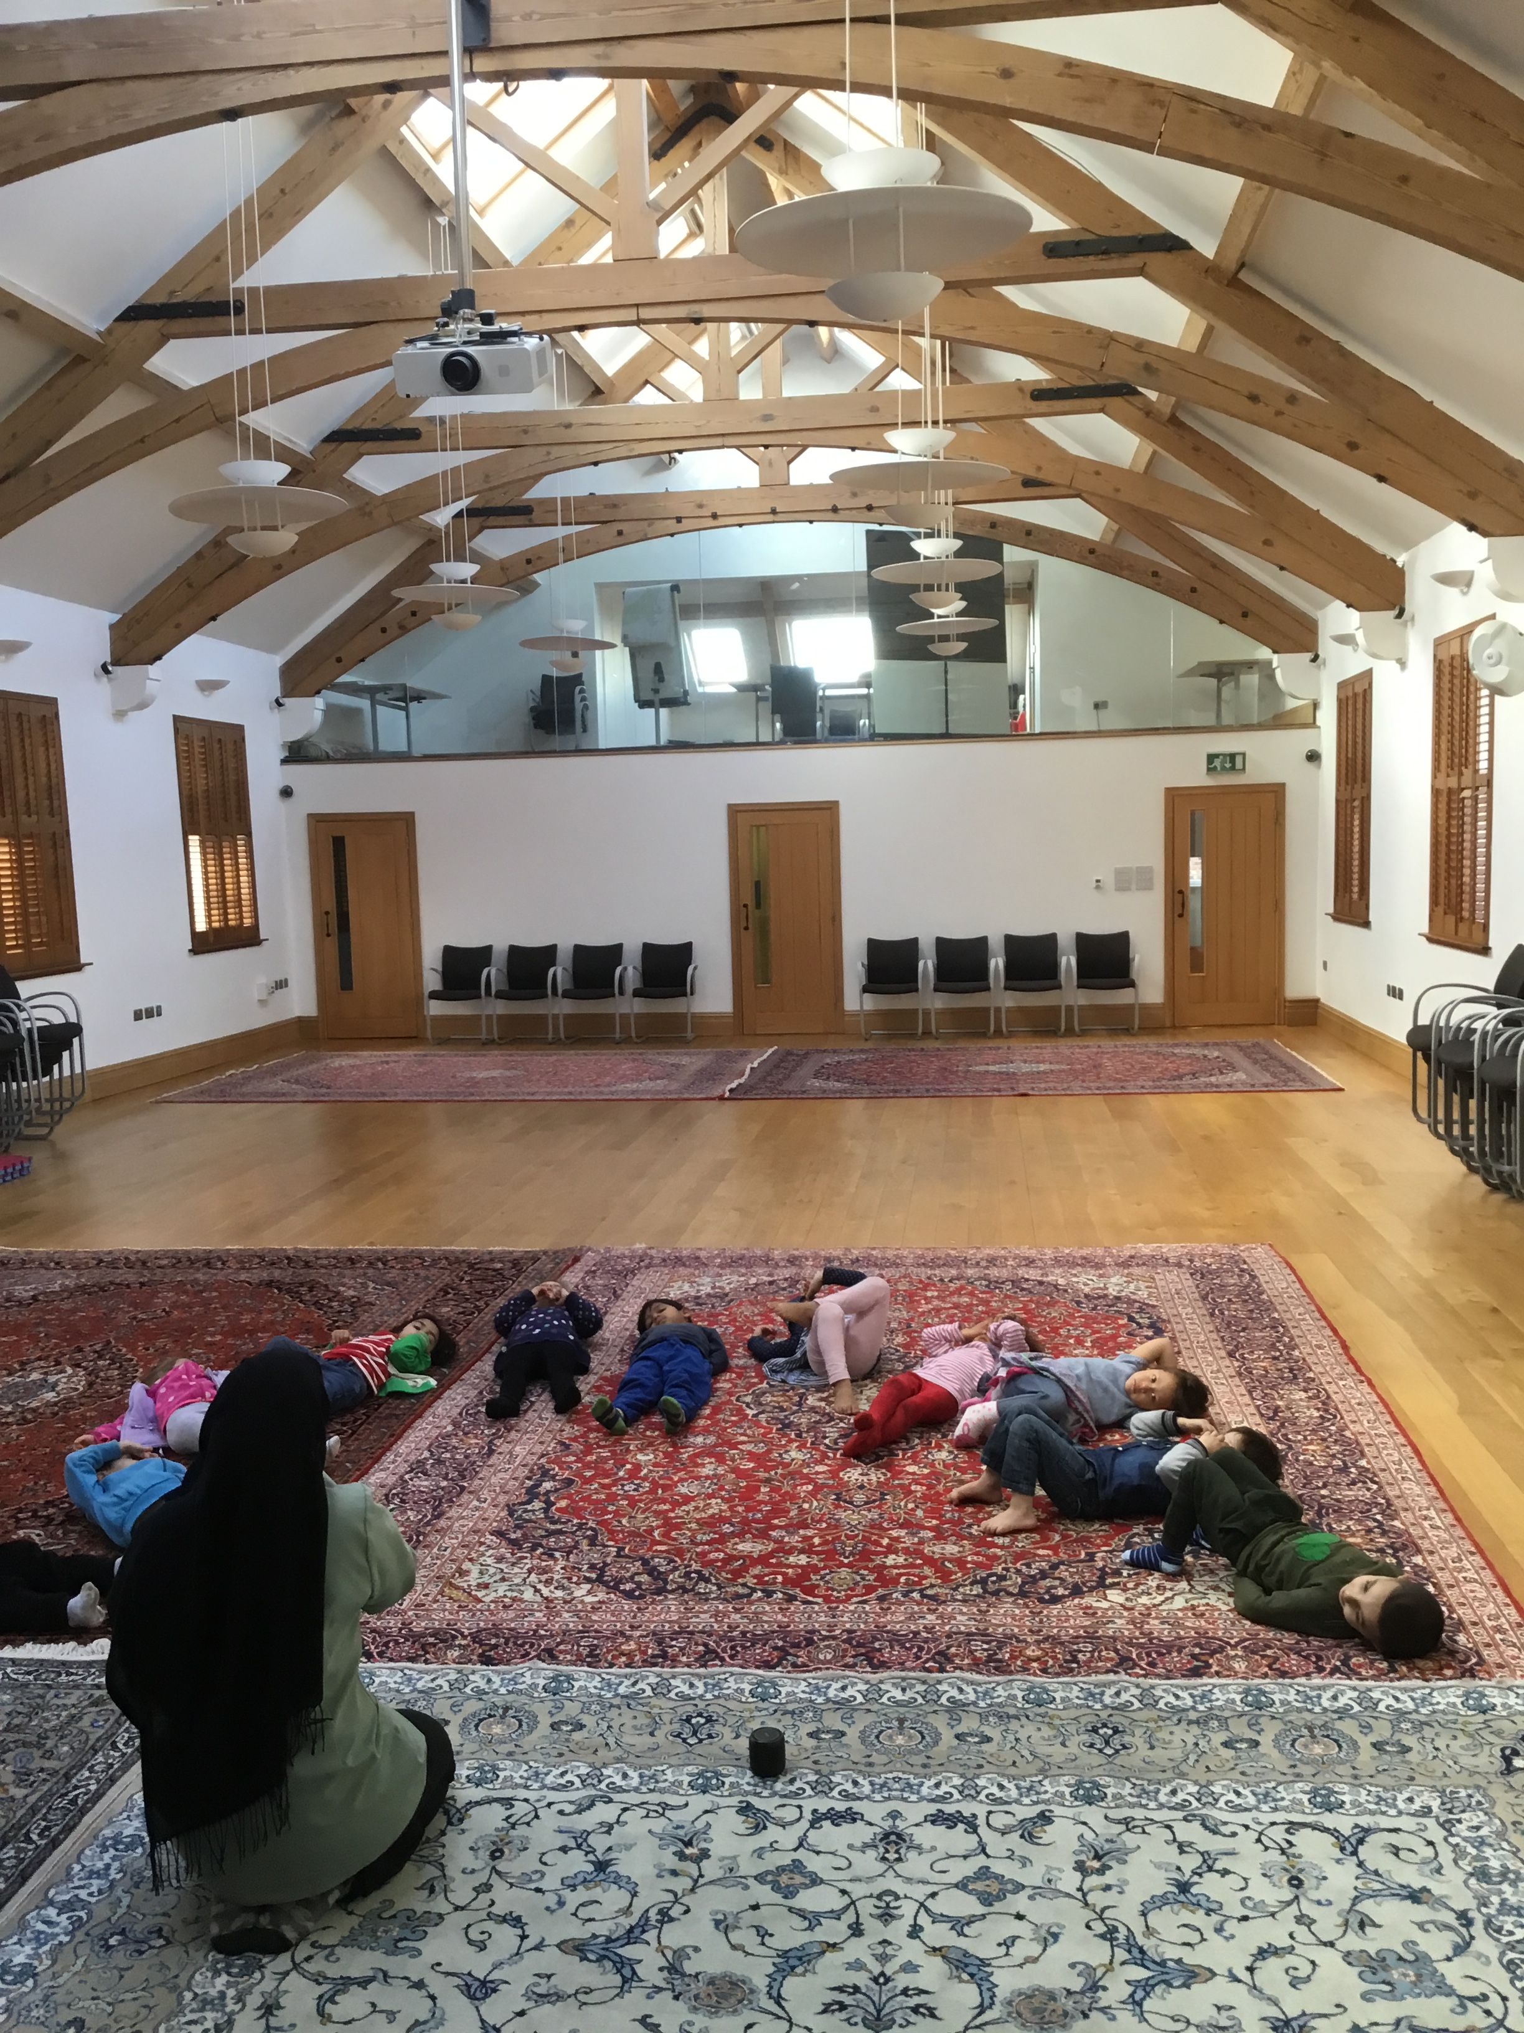

Digging our vegetables and cutting them so we can have them for our snack

