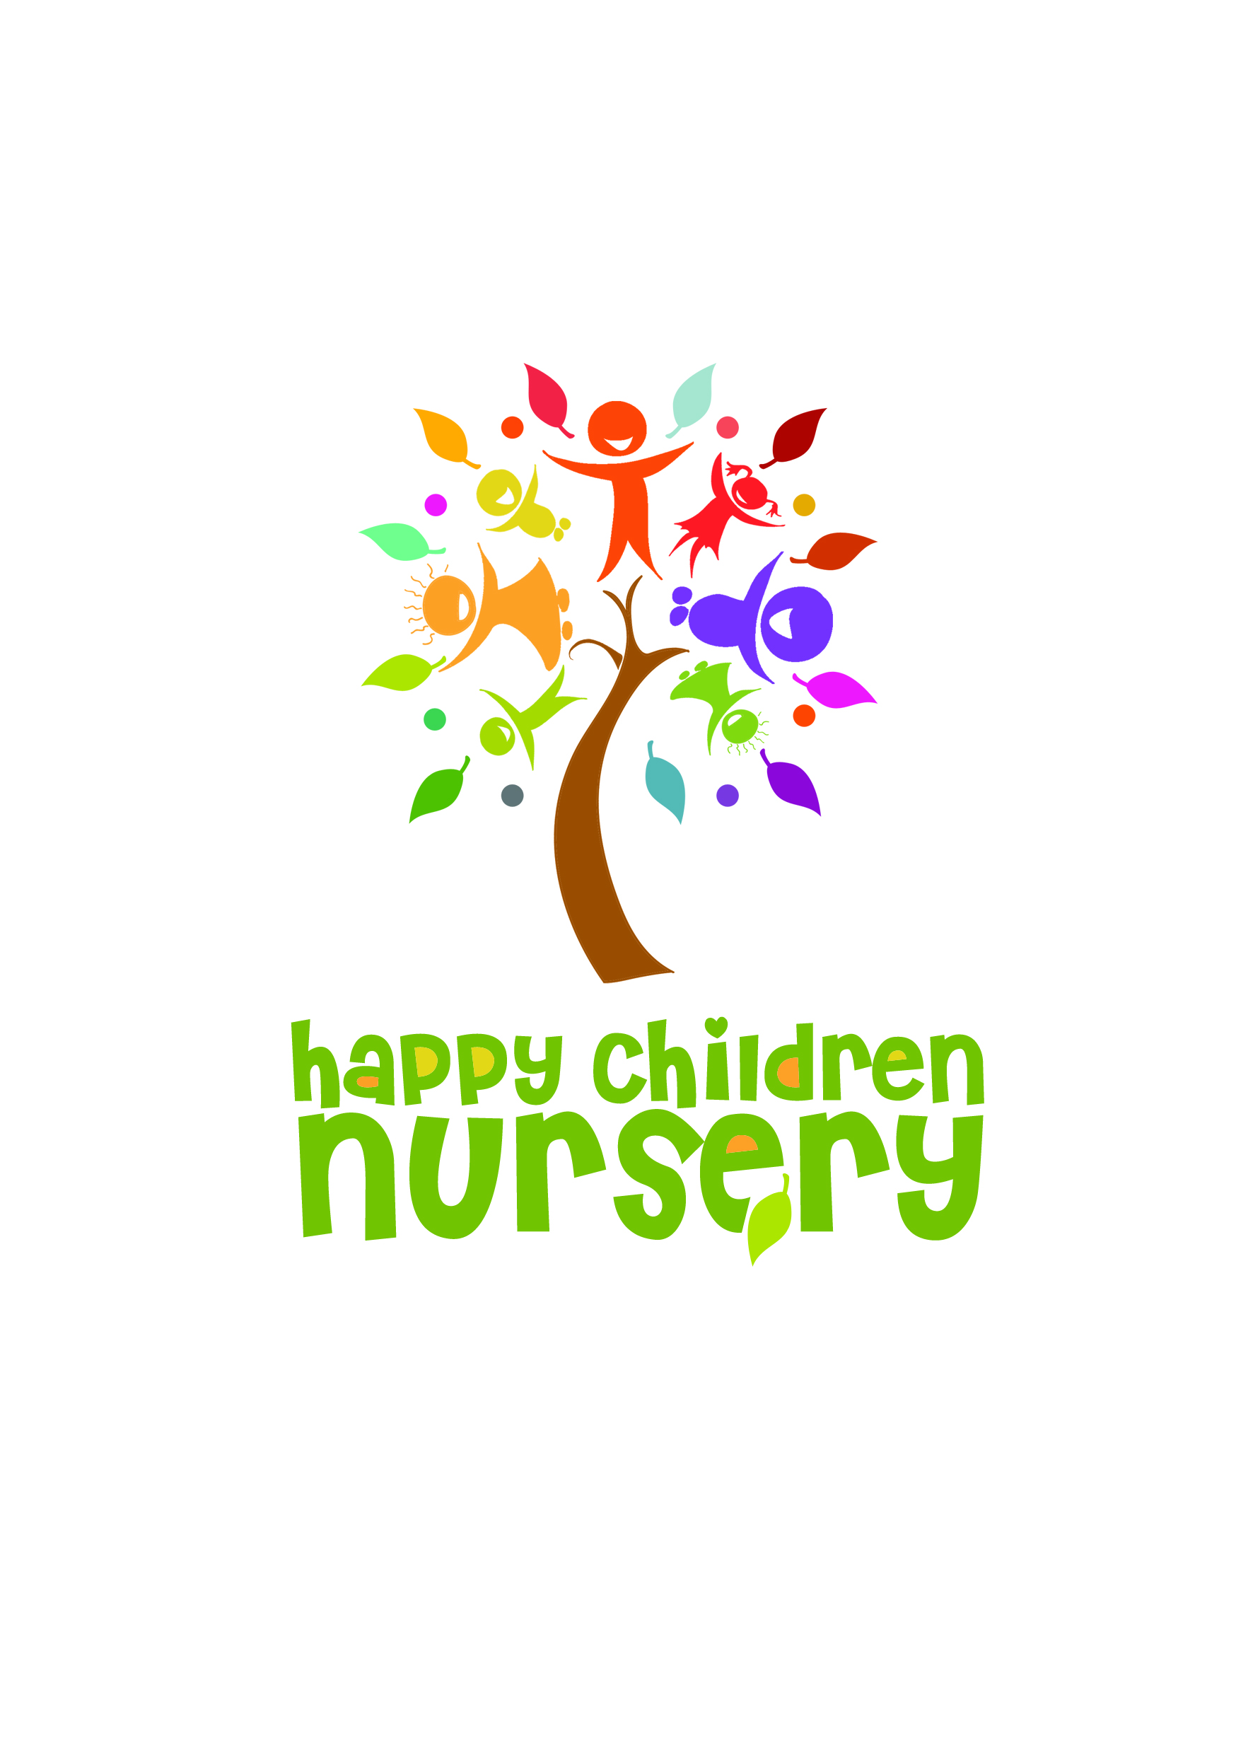 **Parents Newsletter**

Autumn Term 2

Asalam Alaikum / Hello to all Parents and Carers,

We pray you all had a lovely break. We would like to welcome all our new parents and pray your child has settled into the nursery life smoothly.

**Collection for Food Bank**

This term’s theme in the pre-school room is ‘Charity’ as in the past the nursery will be donating non-perishable goods to a food bank. This year we will be donating to ‘The Fans of Liverpool and Everton’ who have pledged to help eradicate poverty in the city. We would like children to collect non-perishable dry foods to donate to the food bank. We can get children involved with the idea of helping others by asking them to collect such items from extended family, neighbours and their parent’s friends. Food can be dropped off in the large basket outside of the nursery entrance or handed directly to staff. The food will be collected week commencing the 16th December 2019. Please note that a group photograph of the children and staff may be taken during this period with the food-bank which will be shared on facebook or other social media which is being used by the food bank, if you would like your child to opt out of this please let the nursery manager know.

**Parents Evening**

Establishing a partnership with our parents is vital to helping our children reach their full potential.

There are large gaps between children entering school from lower income families/families who don’t engage in their child’s education and

those from higher earners/pro active families. We want to close this gap so that our children are in no way disadvantaged, regardless of their parents' circumstances; we believe this can be done through a successful partnership between parents and the nursery. We mention this as each year less than 50% of our parents book an appointment at our parents evening. This means that a partnership of working together to improve our children’s outcomes is not fully established. We hope this year will be different and that all our parents will take time out to learn how best to support their child’s progress. Parents evening will be held on Friday 13th December 2019 between 4.15pm-6pm.

Please book an appointment slot with your key person. Can we please emphasise that if your child

is in nursery that day, you need to pick your child up promptly by 4pm as staff need time to get the

nursery ready for parents evening.

**Pre-schoolers who are going to Reception Sept 2020**

If your child is going to school in September 2020 please ensure you apply for your child’s place,

this can be done online: liverpool.gov.uk/admissions

Please ensure that you apply before the closing date 15th January 2019. If you need any assistance

in applying on-line please ask your key person for support. There are information leaflets on the shelf above the comments box (to the left of the nursery office door) please help yourselves.

**Feedback from parent evaluation from July 2019**

* From the information gathered from our parent evaluation in July this year we wanted to bring to your attention that if you want to share any feedback and feel you cant address a issue with your key person or management you are more than welcome to post this suggestion in the comments box which is situated next to the office door.
* What the children have for their snack is on our website (click ‘about us’ then under healthy eating).

**EasyPeasy programme**

We hope you have found this beneficial so far, the programme is only available for the coming term and then will stop. Please utilise this programme to support your child in meaningful play. If you would like to leave any feedback or suggestions please add comments on the Easy Peasy portal.

**Food and healthy packed lunches**

If your child needs cutlery with their packed lunch the nursery will provide this therefore you don’t need to send it in the packed lunch. If your child is claiming a funded place through the 15/30 hours, we would like to remind you of the 60p per day charge for snacks. Payments should be made on a weekly basis to staff.

We want to thank the majority of parents who have done an amazing job in providing very healthy and creative packed lunches for their child/ren. However we would like to remind you about the hidden sugars in drinks/food such as (fruit shoot, chocolate croissants, yoghurts etc) these foods have a lot of hidden sugars, which we want to bring to your attention and ask if you can avoid putting them in your child’s packed lunch. The nursery provides water and milk throughout the day so please don’t feel obliged to put a drink in the packed lunch. If parents are struggling for alternative ideas and need suggestions in what to prepare for your child’s packed lunch please speak to your key person or manager and we are more than happy to help.

Thank you for taking the time to read our newsletter.

From all the staff at Happy Children Nursery

**Dates for your Diary**

Parents evening- Friday 13th December 2019

Food collection- 16th December 2019

Winter Term ends 19th December and reopens 7th January 2020